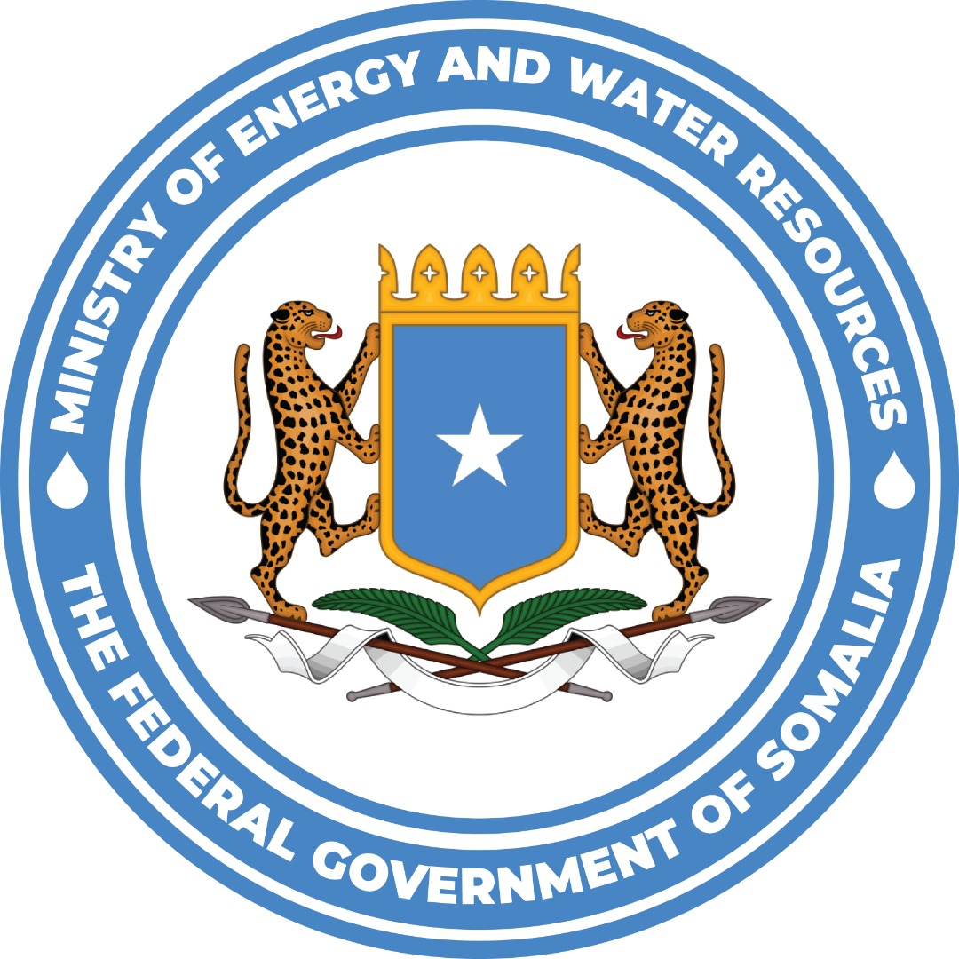

TERMS OF REFERENCE
National Gender Specialist / Gender Expert
Africa Mini-Grids Program (AMP) - Somalia
Tailored assignment to support implementation, monitoring and operationalization of the AMP Somalia Gender Action Plan
Position type | National Gender Specialist
Contract type | Individual Contract
Duty station / location | Ministry of Energy and Water Resources (MoEWR), Mogadishu, Somalia; consultant to be housed/based at the Ministry, and possible field travel to pilot areas
Duration | From contract start date until 31 December 2026; renewable subject to satisfactory performance, continued project needs and availability of funds
Start date | To be confirmed
Supervisor | Director of Energy, MoEWR.

1. Background and project context
The Africa Mini-Grids Program (AMP) is a UNDP-supported and GEF-financed programme that aims to accelerate the deployment of renewable energy mini-grids across Africa. The Somalia national child project seeks to support access to clean energy by increasing the financial viability of low-carbon mini-grids and promoting scaled-up commercial investment in Somalia, with a focus on cost-reduction levers, digital transformation and innovative business models.
The AMP Somalia project is implemented by UNDP Somalia in partnership with the Federal Government of Somalia, particularly the Ministry of Energy and Water Resources (MoEWR), the National Electricity Authority (NEA), relevant Federal Member State authorities and private Electricity Service Providers (ESPs). The project is aligned with SDG 7 on affordable and clean energy, SDG 5 on gender equality, Somalia national development priorities and UNDP country programme priorities on clean, affordable and sustainable energy for economic growth.
The National Transformation Plan (NTP) 2025–2029) identifies the energy sector as a strategic enabler of Somalia's economic transformation, recognizing that reliable, affordable, and sustainable energy is fundamental to industrialization, productive sectors, private sector development, employment creation, and improved social services. The NTP prioritizes expanding energy access and infrastructure, promoting renewable energy development, reviving hydropower potential, advancing responsible oil and gas exploration, and strengthening the extractive sector through institutional reforms and increased investment. Under the NTP, the Government aims to increase national electricity access from 61.9% to 80% of the population by 2029, with particular emphasis on underserved rural communities, internally displaced persons (IDP) settlements, and hard-to-reach areas. This will be achieved through investments in diversified renewable energy sources—including solar, wind, hydropower, decentralized mini-grids, and modern transmission and distribution infrastructure—while promoting public-private partnerships (PPPs) and bankable energy investments to accelerate nationwide electrification and support inclusive economic growth.
Furthermore, the NTP seeks to improve energy affordability and sector efficiency by reducing national electricity tariffs by 50% by 2029 through comprehensive energy sector reforms. Key priorities include strengthening energy governance and regulatory institutions, expanding renewable energy generation, upgrading national grid and transmission networks, encouraging private sector participation through enabling policy and PPP frameworks, establishing technical electricity training institutions, and implementing a Single Buyer Electricity Market Model to integrate Somalia's fragmented electricity systems. The NTP also promotes long-term Power Purchase Agreements (PPAs) with Independent Power Producers (IPPs), modernization of existing mini-grids, and development of a unified national electricity network to improve reliability, reduce operational costs, attract private investment, and ensure sustainable, affordable, and reliable electricity services that contribute to achieving Somalia's broader National Transformation Plan objectives.

2. Rationale for the assignment
The AMP Somalia project has a Gender Marker of GEN-2 and is accompanied by a Gender Analysis and Gender Action Plan (GAP). The GAP Review for AMP Somalia found that foundational gender work has been initiated, including integration of gender considerations in analytical studies, women’s participation in trainings and engagement with women’s organizations. However, the review also found that the GAP remains under-operationalized and lacks a sufficiently measurable framework, including baselines, targets, timelines, responsibilities and dedicated budget lines.
The review further highlighted the absence of a designated Gender Focal Point within the PMU or MoEWR, limited in-house capacity for gender-responsive project management, inconsistent integration of gender requirements into core deliverables, and insufficient tracking of gender results beyond participation numbers. As the project moves into pilot tendering, site-level ESIA/ESMP preparation, PBP implementation, PUE support and monitoring of results, dedicated national gender expertise is required to translate the GAP into practical implementation measures.
This consultancy will provide embedded technical support to the PMU and government counterparts, while being housed/based at the Ministry of Energy and Water Resources (MoEWR), to update and operationalize the GAP; strengthen institutional ownership and capacity; integrate gender into the mini-grid pilots, ESP engagement and ESMP monitoring; and improve gender-sensitive data collection, reporting and learning.

3. Objective of the assignment
The overall objective of the assignment is to provide long-term, embedded gender technical support to MoEWR and UNDP Somalia, to ensure the effective integration of gender equality and women’s empowerment into the planning, tendering, implementation, monitoring, reporting and learning processes of the AMP Somalia project, with particular focus on the mini-grid pilots and related productive-use, financing, digital and capacity-building activities.
  - Specific objectives are to:
- Update and operationalize the AMP Somalia GAP by developing SMART actions, indicators, baselines, targets, timelines, responsibilities and budget estimates.
- Support institutional ownership by strengthening the role of gender focal points and integrating GAP follow-up into PMU, MoEWR/NEA and project governance processes.
- Mainstream gender into the mini-grid pilot cycle, including site-level consultations, ESIA/ESMP processes, ESP contracts, PBP commitments, PUE support, tariff/affordability analysis and digital monitoring.
- Support meaningful participation of women, women-led organizations, female engineers, women entrepreneurs, female-headed households, youth and other vulnerable groups in AMP activities.
- Improve gender-sensitive monitoring, reporting and knowledge management, including PIR inputs, sex-disaggregated data and documentation of lessons learned.

4. Scope of services and main tasks
As a long-term embedded consultant based at MoEWR, the Gender Specialist will provide both milestone-based outputs and continuous day-to-day technical support to the Ministry and the AMP PMU. The role is expected to combine advisory support, hands-on drafting of tools and deliverables, capacity building, coordination with partners, and follow-up on GAP implementation across the pilot cycle.

4.1 Inception, document review and work planning
- Review key AMP Somalia documents, including the ProDoc, Gender Analysis and GAP, GAP Review, Mini-grid Pilot Plan, ESP ToR, M&E framework, stakeholder engagement documents, safeguards documents and relevant annual workplans/reports.
- Hold inception discussions with the AMP Project Manager, MoEWR/NEA, Safeguards and M&E colleagues, the AMP Regional Gender Expert and other relevant stakeholders to confirm scope, priority outputs, timeline and quality expectations.
- Prepare an inception note with methodology, workplan, consultation plan, data needs, draft outline of deliverables and immediate recommendations for priority gender actions during pilot tendering and implementation.

4.2 Update and operationalize the AMP Somalia Gender Action Plan
- Review the existing GAP and update it into a practical implementation matrix aligned with AMP Somalia components, outputs, annual workplans, MPP, tender documents, ESIA/ESMP processes, PBP monitoring and PIR reporting.
- Convert broad GAP actions into SMART actions and indicators with baselines, targets, timelines, responsible parties, means of verification and indicative budgets.
- Prioritize a realistic set of gender actions for the remaining project period, distinguishing between minimum compliance actions and higher-impact gender-responsive actions.
- Identify practical measures to address key gender gaps in access to electricity, energy affordability, access to skills, technical training, decision-making, PUE appliances, finance and energy-sector employment.
- Prepare a short summary note explaining the key changes made to the GAP and how these respond to the findings of the GAP Review.

4.3 Strengthen institutional ownership and internal capacity
- Support the PMU and MoEWR/NEA to clarify responsibilities for GAP implementation and reporting, including proposed Terms of Reference or role descriptions for designated Gender Focal Points within the PMU and/or counterpart institutions.
- Provide routine, on-site technical support to MoEWR on gender-responsive energy planning, documentation, coordination and follow-up of AMP gender commitments, including preparation of meeting notes, action trackers and inputs to ministry-led consultations where required.
- Develop and deliver practical orientation sessions for PMU, MoEWR/NEA, relevant government counterparts and implementation partners on gender-responsive mini-grid planning, inclusive consultation, sex-disaggregated data collection, PUE targeting and reporting.
- Prepare simple tools for the PMU to track gender commitments in monthly/quarterly reviews, Project Board updates, Annual Work Plans, PIRs and technical deliverables.
- Advise on integrating gender responsibilities into ToRs, contracts and scopes of work for technical consultants, verifiers, ESIA/ESMP teams, trainers and other service providers.

4.4 Integrate gender into mini-grid pilot implementation
- Provide gender inputs to site-level planning for the three AMP pilot lots and the selected pilot sites, including community entry approaches, inclusive stakeholder mapping and targeted engagement of women, youth, female-headed households, women-led businesses, social facilities and vulnerable groups.
- Support the design or review of gender-sensitive consultation tools, including focus group discussion guides, key informant interview guides and consent/safeguarding protocols appropriate to the Somali context.
- Advise the ESIA/ESMP process to ensure it captures gender-differentiated risks and benefits, including access, affordability, safety, land/use rights, employment, grievance redress, labor conditions, SEA/SH risk awareness and do-no-harm considerations.
- Support integration of gender commitments into ESP implementation plans and ESMPs, including targets for women’s participation in implementation roles, customer service, outreach, local employment, leadership and training where feasible.
- Advise on gender-responsive approaches to connections, tariffs and affordability analysis, including female-headed households, women-led enterprises and institutions that primarily serve women and girls.
- Support PUE planning by identifying women-led or women-managed enterprises that could benefit from electricity access and PUE equipment, including businesses in food processing, milk/ghee production, cold storage, milling, water pumping, refrigeration, retail and other locally viable activities.

4.5 Support ESP engagement, tendering and Performance-Based Payment monitoring
- Review gender equality and social inclusion provisions in ESP tender documents, evaluation criteria, grant/PBP agreements and verification tools, and propose practical improvements where needed.
- Develop a gender and social inclusion checklist for reviewing ESP proposals and implementation plans, covering women’s access to electricity, women-led business support, female employment, customer outreach, grievance mechanisms, safe consultations and sex-disaggregated reporting.
- Advise on how gender commitments should be monitored during the first three months of operation and reflected in ESMP compliance and PBP verification, including how non-compliance with agreed gender commitments should be documented and addressed.
- Support the Ministry and PMU to develop guidance for ESPs on gender-responsive customer engagement, PUE leasing arrangements, fair contracts for women-led businesses and reporting of gender results.

4.6 Partnerships, community engagement and women’s economic empowerment
- Map relevant women’s organizations, women’s networks, women-led MSMEs, female engineers, vocational institutions, community groups and civil society actors that can support gender-responsive implementation of AMP Somalia.
- Support targeted outreach to women’s networks, such as Women in Energy Somalia, SWEDA and relevant local organizations, to identify opportunities for participation in consultation, training, pilot monitoring, awareness raising and women-led enterprise support.
- Design practical awareness-raising messages and materials for women and communities on mini-grid services, connection processes, customer rights and responsibilities, PUE opportunities, grievance channels and safeguards.
- Identify opportunities for internships, apprenticeships or training pathways for women engineers, female TVET graduates and young women interested in mini-grid installation, operations, maintenance, customer service and energy entrepreneurship.

4.7 Monitoring, reporting, learning and knowledge management
- Develop a GAP monitoring and reporting tool that enables the PMU to report at least twice per year on GAP progress, including sex- and age-disaggregated data and outcome-oriented indicators.
- Support integration of gender-sensitive indicators into M&E tools, the AMP digital platform where applicable, site-level monitoring, ESP reporting templates and PIR inputs.
- Prepare concise reporting language for AMP Somalia on gender progress, challenges, risks, adaptive actions and lessons learned for use in PIRs, Project Board reports, donor briefs and knowledge products.
- Document at least one potential success story, case example or learning note on gender and mini-grids in the Somalia AMP context, with attention to women-led businesses, women engineers, PUE, women’s access to clean electricity or inclusive pilot implementation.
- Prepare a final assignment report summarizing outputs delivered, consultations conducted, key findings, updated tools, remaining gaps and priority recommendations for continued GAP implementation.

5. Expected deliverables and payment schedule
The consultant will produce concise, practical and editable deliverables in Word/Excel/PowerPoint formats as appropriate. Given the long-term nature of the assignment, deliverables will include both milestone-based outputs and continuous monthly technical support to MoEWR and the AMP PMU. Deliverables will be reviewed and cleared by the AMP Project Manager in consultation with the PMU, MoEWR/NEA and relevant UNDP technical teams. The table below provides an indicative structure that may be adjusted during inception and contract finalization.

No. | Deliverable / output | Timing / frequency | Approval / payment basis
1 | Inception note and detailed workplan, including document review matrix, consultation plan, data needs and agreed priority actions for MoEWR/PMU support. | Within the first 10 working days of the assignment | Acceptance of inception package by AMP Project Manager
2 | Updated, costed and operationalized AMP Somalia GAP, including SMART actions, indicators, baselines, targets, responsibilities, timeline, budget estimates and a summary note of key changes. | Within the first 4-6 weeks, then updated as needed | Acceptance of updated GAP package
3 | Continuous embedded technical support to MoEWR and AMP PMU, including review of ToRs, tender/gender provisions, ESP guidance, safeguards inputs, meeting notes, action trackers and monthly advisory notes. | Monthly throughout the contract period | Accepted monthly progress report/timesheet and evidence of outputs delivered
4 | Gender-responsive pilot implementation package, including site consultation tools, PUE/gender checklist, ESP gender/social inclusion checklist, gender-sensitive ESMP inputs and guidance for ESP customer engagement. | During pilot tendering, site planning and early implementation | Acceptance of pilot implementation package and related tools
5 | Capacity-building and stakeholder engagement package, including training/orientation materials and delivery of practical sessions for MoEWR/NEA, PMU, ESPs, women’s organizations and relevant partners. | At least two sessions, and additional support as required before 31 December 2026 | Acceptance of training materials, attendance records and short session reports
6 | GAP monitoring, reporting and learning package, including monthly progress updates, biannual GAP reporting inputs, sex-disaggregated data tools, PIR/Project Board inputs, knowledge product/success story and final assignment report. | Monthly and at key reporting milestones; final report by 31 December 2026 | Acceptance of monitoring/reporting package and final report

The assignment is expected to run from the contract start date until 31 December 2026. The contract may be renewed subject to satisfactory performance, continued project needs, availability of funds and UNDP procedures. Payment arrangements should be aligned with the selected contract modality and may be made against accepted monthly progress reports/timesheets and/or agreed milestone deliverables.

6. Institutional arrangements and coordination
The consultant will report to the Director of energy department at MOEWR. The consultant will be housed/based at MoEWR and will maintain day-to-day coordination with the UNDP AMP PMU team.
The consultant will work closely with the MoEWR/NEA and PMU focal points, UNDP Somalia Safeguards, M&E, Procurement and Programme teams, and relevant Federal Member State/local authorities as needed. As an embedded resource at MoEWR, the consultant is expected to support routine coordination, follow-up, documentation and capacity strengthening related to GAP implementation.
The consultant will coordinate technically with the AMP Regional Gender Expert and/or Regional AMP team for quality assurance, alignment with AMP tools and sharing of lessons from other AMP countries.
The consultant will coordinate with ESPs, women’s organizations, training institutions, civil society actors and community representatives only through arrangements agreed with MoEWR and UNDP and in line with stakeholder engagement protocols.

7. Duty station, duration and travel
The consultant will be based/housed at the Ministry of Energy and Water Resources (MoEWR) in Mogadishu, Somalia, with regular coordination with the UNDP AMP PMU. The assignment will run from the contract start date until 31 December 2026 and is renewable subject to satisfactory performance, continued project needs, availability of funds and UNDP procedures. Possible field travel to selected pilot sites will be subject to MoEWR and UNDP operational requirements and availability of resources.

8. Required profile and qualifications

8.1 Education
Advanced university degree (Master’s or equivalent) in gender studies, gender and development, social sciences, development studies, sustainable energy, environmental studies, economics or a related field.
A first-level university degree with additional qualifying experience may be accepted in lieu of an advanced degree, in line with UNDP requirements.

8.2 Experience
- At least 7 years of relevant professional experience in gender mainstreaming, gender analysis and/or gender-responsive programme implementation in development settings.
- Demonstrated experience developing or updating Gender Action Plans, gender-sensitive indicators, M&E tools, reporting frameworks and practical implementation guidance.
- Experience working in energy access, renewable energy, infrastructure, private sector development, productive-use programmes, climate change or basic services is highly desirable.
- Experience working with government institutions, UN agencies, donors, civil society organizations, women’s networks and private-sector actors in Somalia or comparable fragile/conflict-affected contexts is an asset.
- Experience facilitating inclusive consultations, training workshops and stakeholder engagement processes with women, youth, vulnerable groups and community-based organizations.
- Strong understanding of gender equality, social inclusion, do-no-harm principles and gender-related risks in community infrastructure and service-delivery projects.
- Knowledge of UNDP/GEF programming, Gender Marker requirements, safeguards, SES/ESMP processes, PIR reporting or results-based financing modalities is an advantage.

8.3 Skills and competencies
- Strong analytical, drafting and communication skills, with ability to prepare concise, practical and operational deliverables.
- Ability to translate gender analysis into implementable actions, indicators, budgets, contract clauses and monitoring tools.
- Ability to work collaboratively with technical teams, regulators, ESPs, government counterparts and civil society stakeholders.
- Excellent facilitation skills and sensitivity to cultural, security and access constraints in Somalia.
- Proficiency in English is required. Proficiency in Somali is required or strongly preferred for community engagement and stakeholder consultations.

9. Evaluation criteria (indicative)
Criteria | Weight
Technical qualification and relevant experience | 40%
Demonstrated experience in gender action plans, indicators, M&E and reporting | 25%
Experience in energy access, infrastructure, private sector, climate or productive-use programming | 15%
Knowledge of Somalia context and ability to work with government, CSOs and communities | 10%
Quality of methodology/approach and financial proposal | 10%

10. Key principles and quality requirements
- Gender-responsive and practical: recommendations should correct identified imbalances and be feasible within AMP Somalia’s budget, timeline and operating context.
- Context-specific: all tools and guidance should reflect Somalia’s private-sector-led electricity market, pilot lot structure, security constraints, cultural norms and institutional arrangements.
- Evidence-based: all proposed indicators and targets should be measurable through available or reasonably collectable data, including sex- and age-disaggregated information.
- Do-no-harm: consultations and pilot activities should avoid reinforcing stereotypes, unpaid labor burdens, exclusion, SEA/SH risks or conflict-sensitive harms.
- Operationally useful: deliverables should be concise, editable and immediately usable by the PMU, MoEWR/NEA, ESPs and implementation partners.

Annex 1. Indicative gender results areas and indicators for AMP Somalia
The consultant will refine these indicators during the assignment and align them with the GAP, M&E framework, ESP reporting templates, ESMP monitoring and PIR requirements.
Results area | Indicative indicators / evidence
Electricity access and affordability | Number and percentage of women-headed households newly connected; connection rates among female-headed households; affordability feedback from women customers; number of institutions serving women and girls connected.
Women-led enterprises and PUE | Number and percentage of women-owned or women-led enterprises connected; number of women-led enterprises supported with PUE equipment or leasing arrangements; type of PUE equipment used by women-led businesses; changes in operating hours, income proxy or productivity where feasible.
Training, jobs and leadership | Number and percentage of women participating in AMP-supported trainings, apprenticeships, internships and community sessions; number and percentage of women in implementation, customer service, outreach or leadership roles among ESPs/partners; number of women engineers or TVET graduates engaged.
Participation and decision-making | Number of consultations held with women and women’s organizations; number of women’s organizations engaged at pilot level; evidence that women’s feedback influenced pilot design, PUE targeting, customer engagement or safeguards measures.
ESP gender commitments | Number and percentage of ESP proposals with acceptable gender/social inclusion measures; implementation status of agreed gender commitments in ESMP/PBP monitoring; corrective actions taken where commitments are not met.
Digital monitoring and data | Number of monitoring indicators disaggregated by sex and age where applicable; evidence that sex-disaggregated data is used to inform pilot targeting, affordability analysis, PUE planning and adaptive management.
Safeguards and grievance redress | Number of grievances received and resolved disaggregated by sex where safe and appropriate; evidence of women-friendly grievance channels; SEA/SH risk awareness and do-no-harm measures integrated in consultations and ESMP implementation.
Knowledge and learning | Number of knowledge products, success stories or technical briefs on gender and mini-grids; gender agenda items included in AMP Community of Practice, Project Board or learning meetings.

Language Requirements
- Fluency in English and Somali (spoken and written) is required, with the ability to prepare technical reports and facilitate stakeholder engagements in both languages.
Application Process:
Interested candidates should submit a detailed proposal outlining their key expert’s qualifications, relevant experience, proposed methodology, and preferred payment option(s) to procurement@moewr.gov.so cc: dg@moewr.gov.so energy@moewr.gov.so by submission deadline of 18th September 2026.
Confidentiality:
All information provided to the consultant during the course of the consultancy shall be treated as confidential and shall not be disclosed to any third party without prior written consent from MoEWR.

